

**INSTALLATION MANUAL**

**Table of Contents**

1. **Applicable Version**
2. **Installation Kit**
3. **Configuring Worldlien**
4. **Feature List**

**Applicable Versions**

| **Applications** | **Versions** |
| --- | --- |
| **PHP** | **≥ 5.6, < 8.2** |

**Installation Kit**

Please follow the given steps to install and run the worldline Payment Gateway module

1. Browse the provided zip folder and click it and download it .
2. Unzip that folder and place into www or htdocs folder
3. for the start of the worldline kit [http://<your-hostname>/](http://127.0.0.1:8000/start)projectname/index.php

**Update kit**

1. Go to the “\xampp\htdocs\unzip_folder” delete the old folder from htdocs and put the new folder there.
2. Follow the same process as mentioned above

**Configuring worldline**

1. Go to the admin Page [http://<your-hostname>/](http://127.0.0.1:8000/admin)projectname/[admin](http://127.0.0.1:8000/admin).php
2. Scroll down . You will see Worldline settings , edit it.
3. Configure it as below :

| **Column Name** | **Description** |
| --- | --- |
| Merchant Code | Enter your merchant code |
| Salt / Key | Enter your salt or Encryption key |
| Payment Type | For test mode select “Test” for live mode select “Live” |
| Merchant Scheme Code | Enter Scheme code |

1. Now click on “Submit” on the bottom-right corner.
2. Worldline Payment Gateway is now configured & ready to use.

**Advanced Configuration**

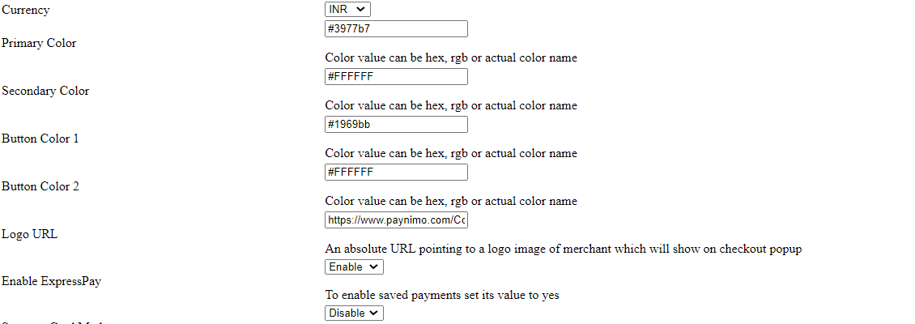

**Features List**

**Online Transaction:**

To make an online transaction go to [http://<your-hostname>/projectname/offline_verification.php](http://localhost/projectname/admin.php) .

**Dual verification of response:**

We validate responses with a hash value and call the Payment Gateway for dual verification from the payment gateway before updating to the order status.

S2S Verification :

If we do not receive any response from the payment gateway then after 30 mins, we will get a response from the server and based on the response it will update order status. To configure the S2S URL, contact the prod team.

S2S url format : http://<your-hostname>/s2s.php?msg=

Example:

http://<your-hostname>/s2s.php?msg=0300|success|NA|12846079|470|1411243270|5.00|{itc:}{c[%E2%80%A6]f93dd72dc9c05fa0fa1601fb85d74d3e3177e7b2f3f111b08f542681077cq

**MCG**

It supports multi currency like INR & USD and a lot more can be added.

**worldline Offline Verification**

Merchants can verify the status of their payment by using the Payment Verification page. The payment verification page can be found at [http://<your-hostname>/offline_verification](http://localhost:3000/payment/offline-verification)

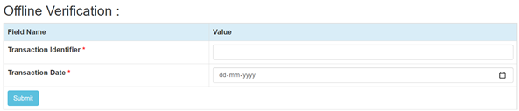

**Reconciliation**

Merchants can update the pending status of the order automatically if the payments are

successful. This page can be found at [http://<your-hostname>/reconciliation](http://localhost/reconciliation.php).php

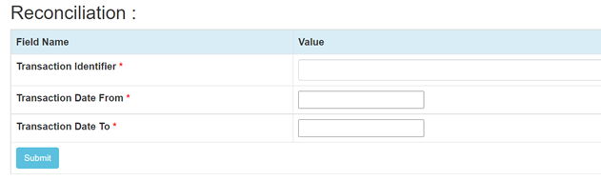

**Refund**

Merchants should be able to process the refund online for the order whose payment has been done via worldline. To refund an order go to [http://<your-hostname>/refund](http://localhost/refund.php).php

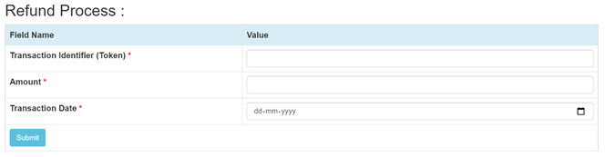

**Embed Payment Gateway On Page**

After enabling this setting, payment gateway displays like embedded on the page instead of pop-up so user experience would be good.

**E-mandate/E-Nach/SI**

**Configuration**

1. Go-to http://<your-hostname>/admin.php
2. Configure it as below

| **Column Name** | **Description** |
| --- | --- |
| **Enable eMandate/SI** | **“Enable” this flag to use E-mandate/E-nach/SI** |

1. **Now click on “submit” on the bottom.**
2. **Worldline Payment Gateway with E-mandate is now configured & ready to use.**

**Advanced Configuration**

There are also some advanced configuration options you may consider as shown below:

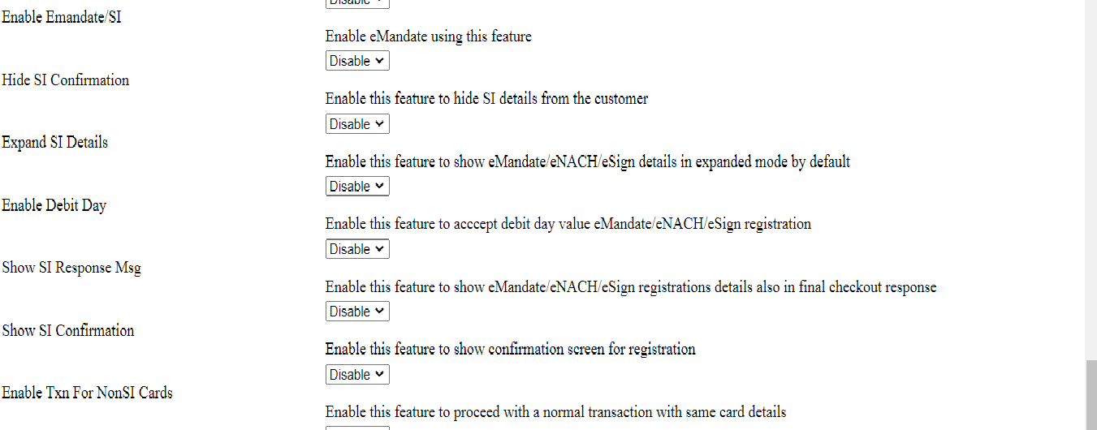

**Mandate Registration**

1. Go-to http://<your-hostname>/projectname/index.php
2. Fill the necessary fields for transaction
3. Click on “Submit” button to get the E-mandate Pop up
4. Fill the necessary fields on pop -up and click complete the transaction to register the mandate.

## **Features List**

**Mandate Verification**

Merchants can verify the status of their Registered Mandate/SI by using the Mandate Verification page.The Mandate verification page can be found at [http://<your-hostname>/emandate-si/mandate_verification.php](http://localhost/emandate-si/mandate_verification.php)

We need to pass Consumer ID used in Online Transaction

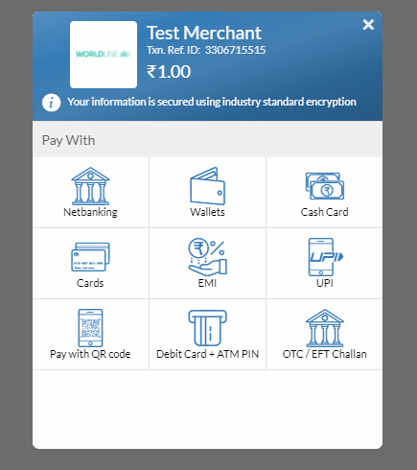

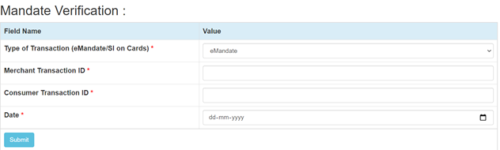

**Transaction Scheduling**

Merchants can Schedule their Transactions for Mandate/SI by using the Transaction Scheduling page. The Transaction Scheduling page can be found at

[http://<your-hostname>/emandate-si/transaction-scheduling.php](http://localhost/emandate-si/transaction-scheduling.php)

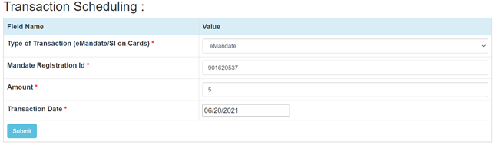

**Transaction Verification**

Merchants can verify the status of their Scheduled Transactions for Mandate/SI by using the Transaction Verification page. The Transaction Verification page can be found at

[http://<your-hostname>/](http://localhost/emandate-si/transaction_verification.php)emandate-si/transaction_verification.php

We need to pass the Merchant Transaction Reg No given in Transaction Scheduling response

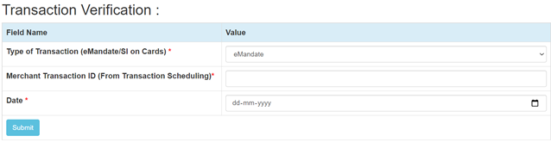

**Mandate Deactivation**

Merchants can deactivate the registered Transaction for Mandate/SI by using the Mandate Deactivation page. The Mandate Deactivation page can be found at

[http://<your-hostname>/emandate-si/mandate-deactivation.php](http://localhost/emandate-si/mandate-deactivation.php)

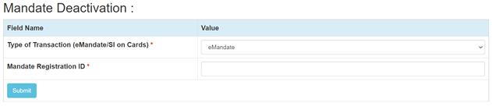

**Stop Payment**

Merchants can Stop the scheduled transaction by using the Stop Payment page. The Stop Payment page can be found at

[**http://<your-hostname>**/emandate-si/**stop_payment**](http://localhost/emandate-si/stop_payment)**.php**

**We need to pass TPSL Transaction ID given in Transaction Scheduling response**

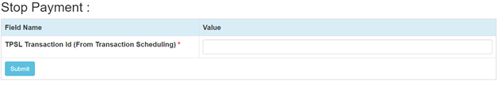

**Documentation link:**

[**https://github.com/Worldline-Ind/PHP-CHECKOUTJS**](https://github.com/Worldline-Ind/PHP-CHECKOUTJS)